Database Tables

* Product Table  
  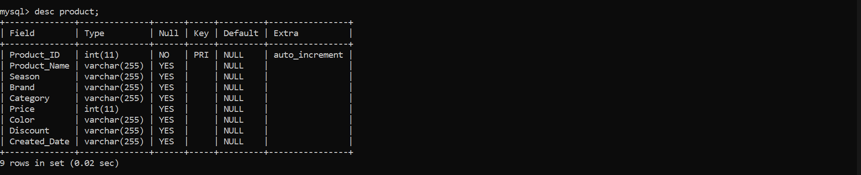
* User Table  
  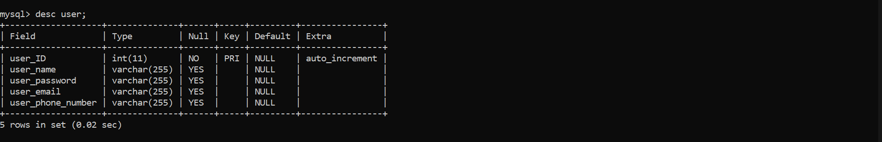

Initially User table has two entries admin and a normal user.  


Product Table is empty.  


Once the Spring Boot starts and the API works the admin can add the product through Postman API’s.  
Pre request script to add system date while modifying/adding product details.  
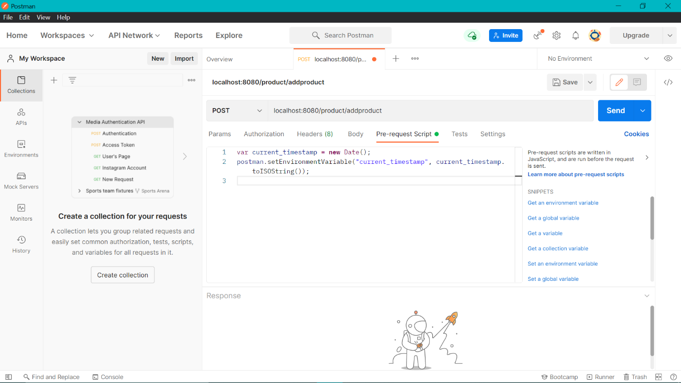

Adding the product.

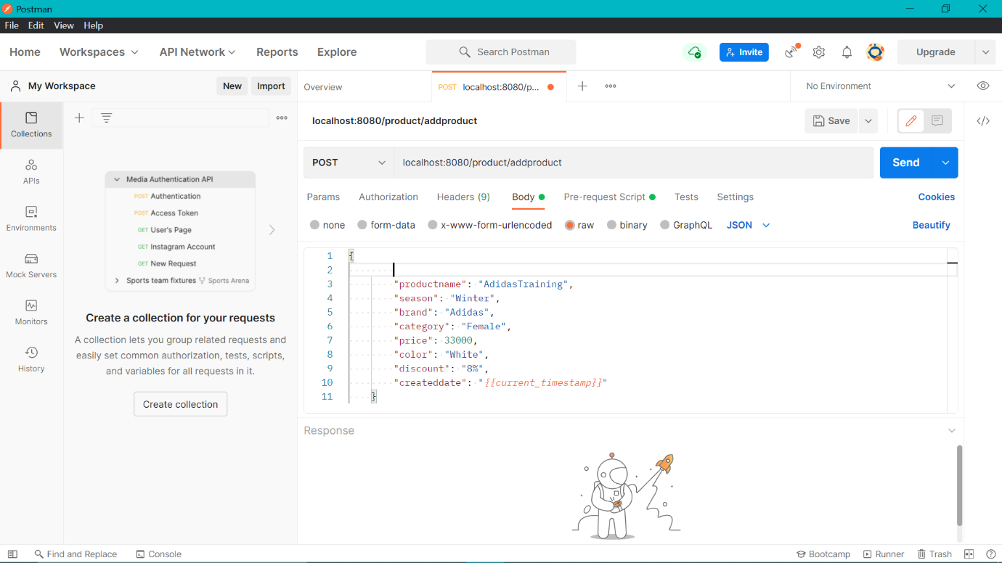  
  
Product added through POST.  
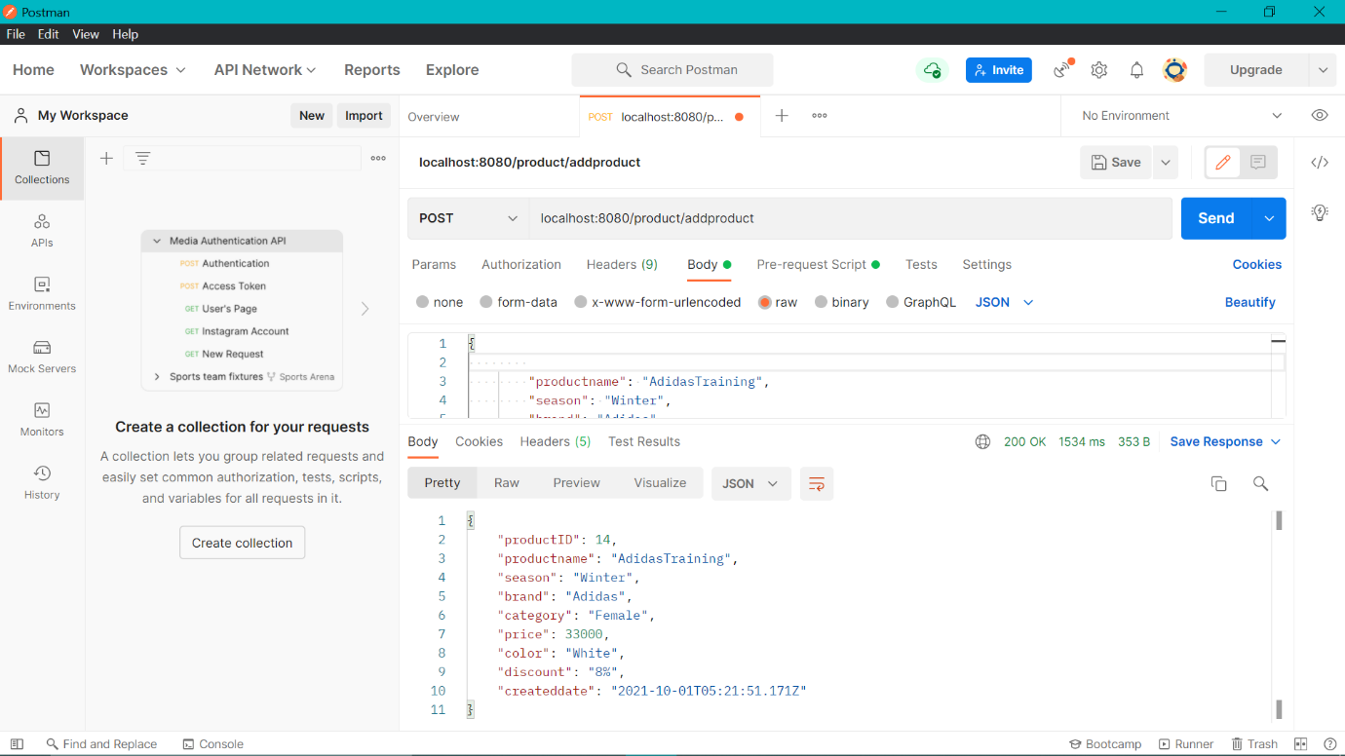

Pre Request Script to add system date while modifying product details.  


The changes are visible into database tables.  
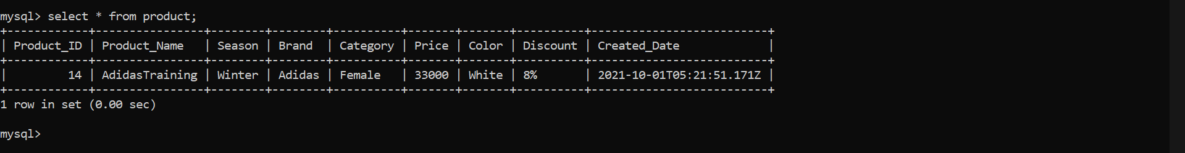

Similarly, further new products can be added.  
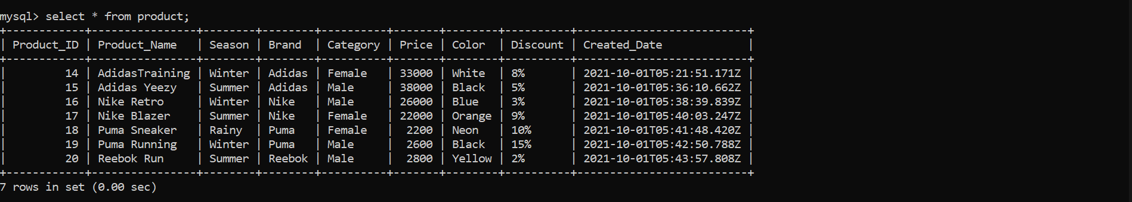

Delete an added product.  
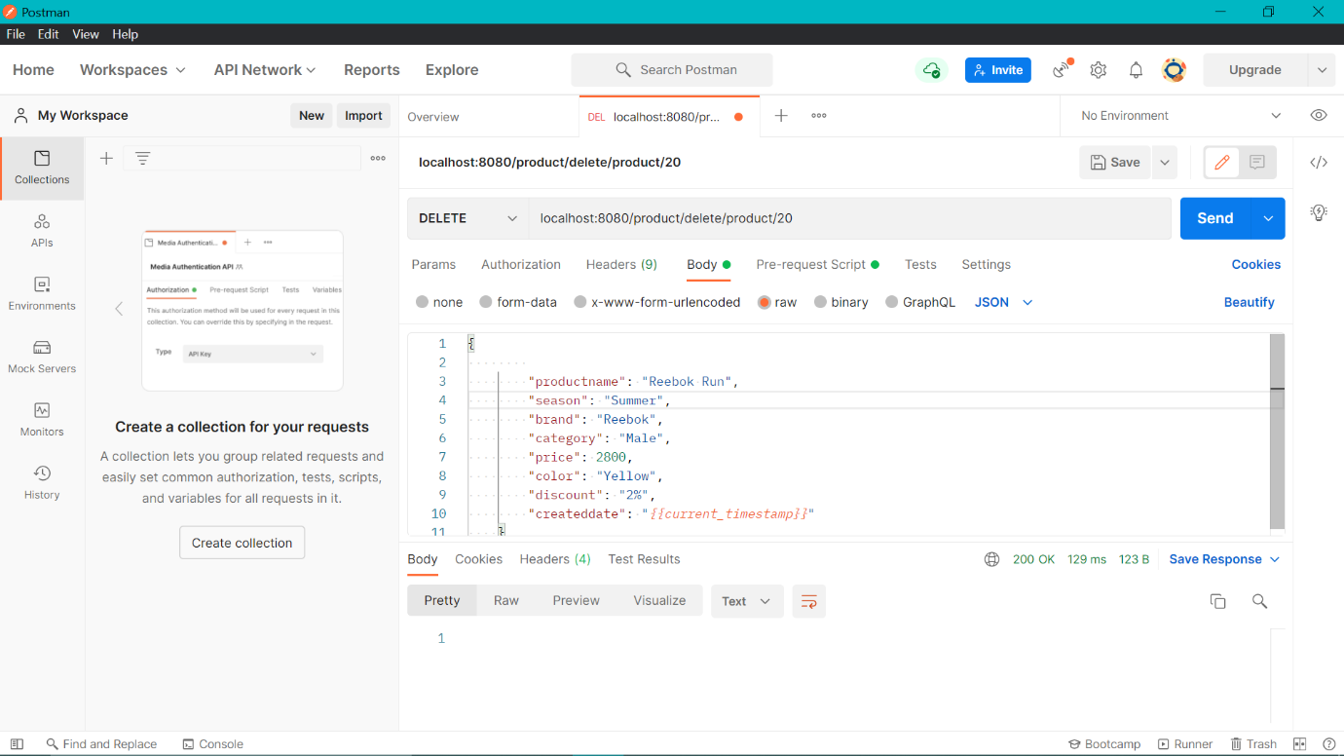

In database table  
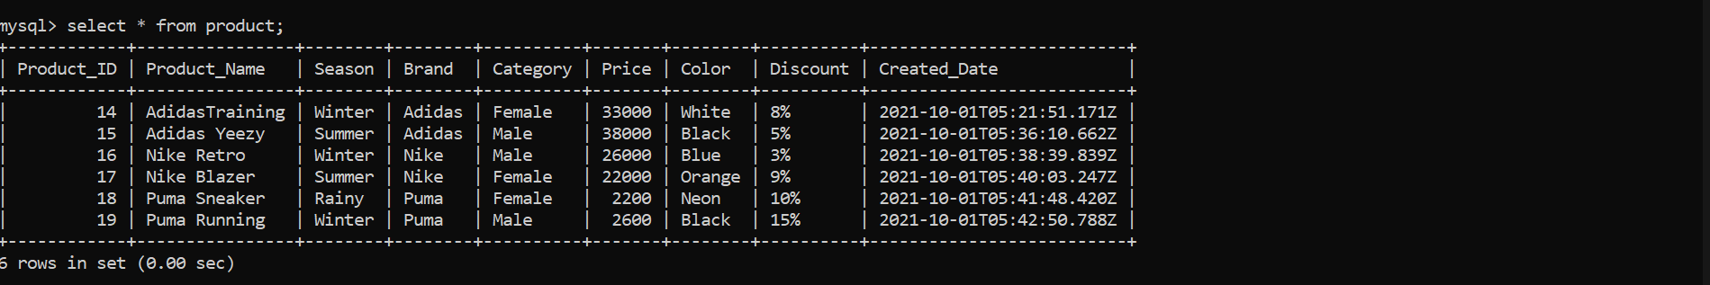

Updating existing product details  
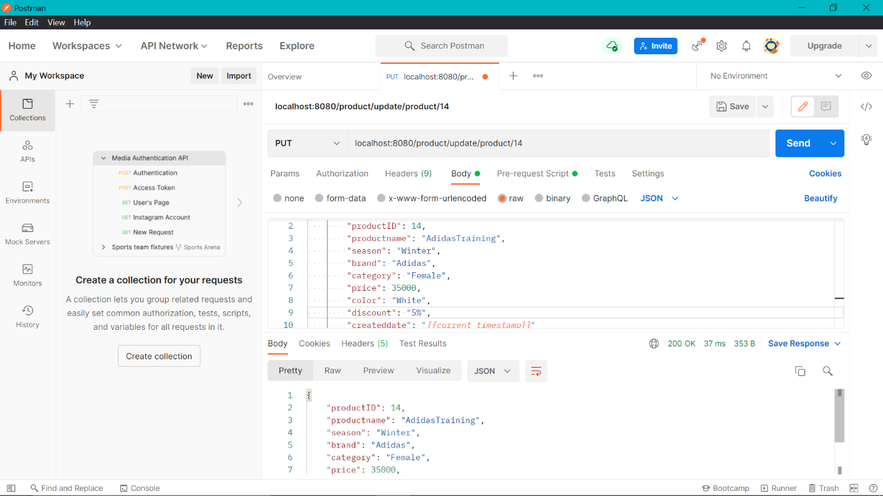

In database table the price and discount has been updated.  
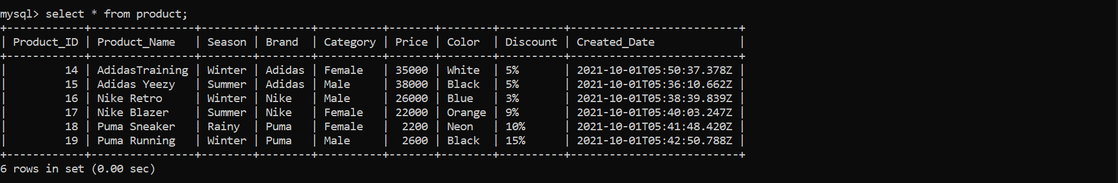

Searching through Filters  
 1. Season (Winter)  
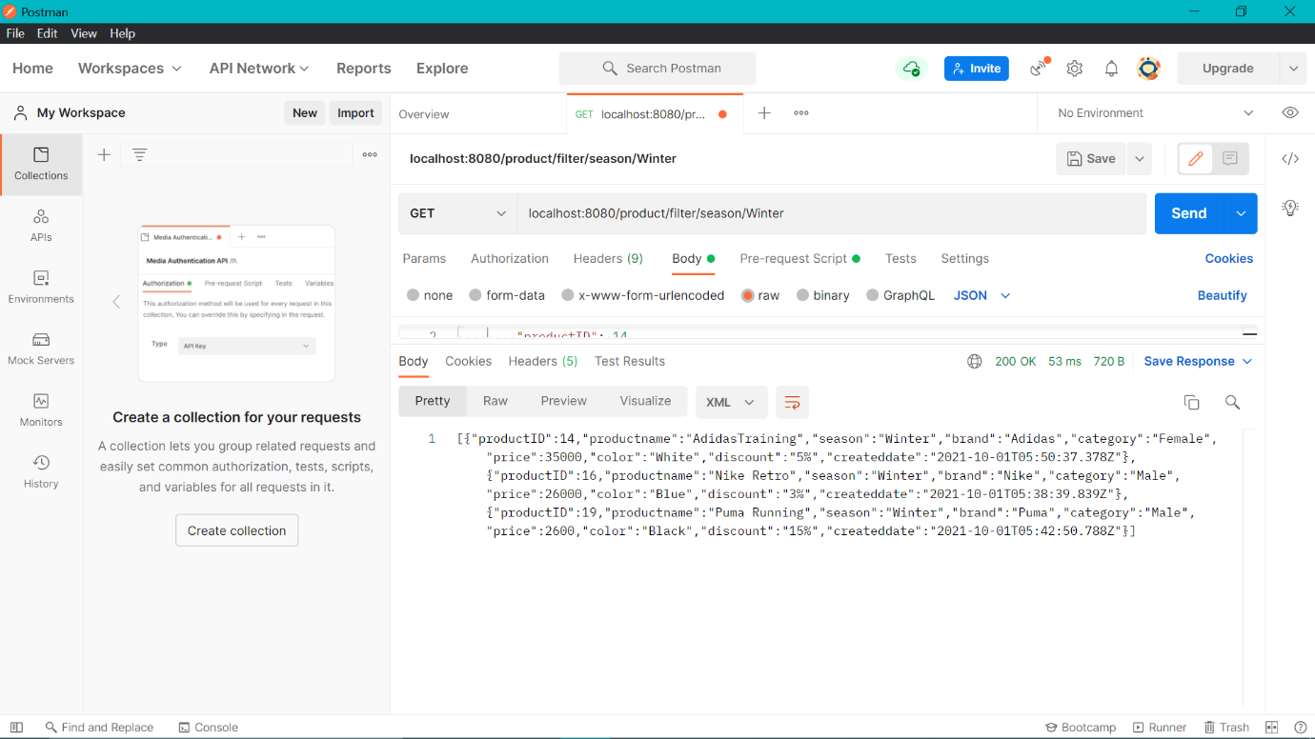

Season (Rainy)  
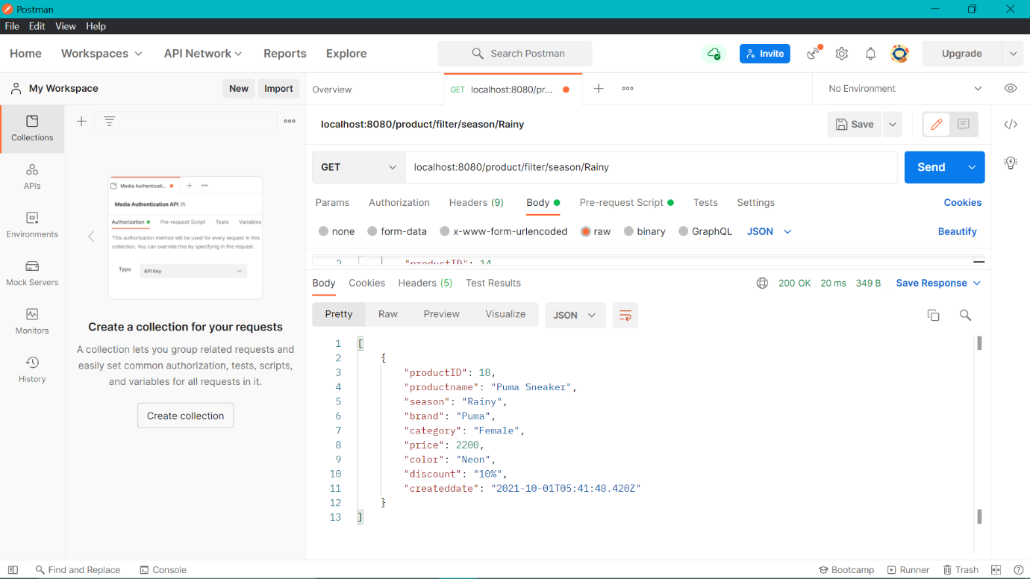

Season (Summer)  
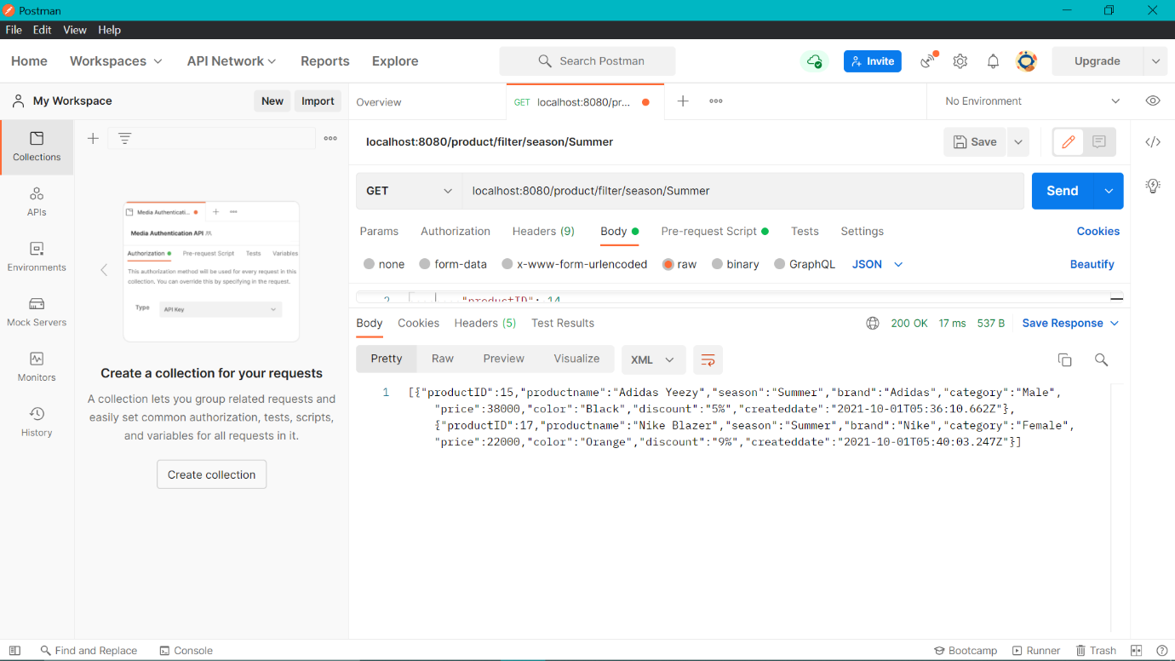

2. Brand (Nike)  
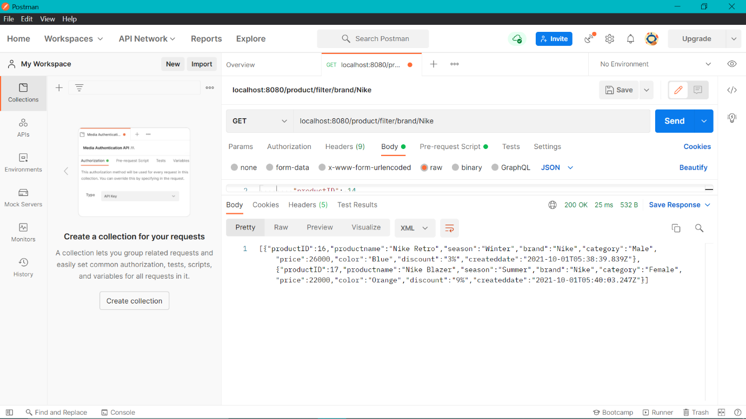

Brand (Adidas)  
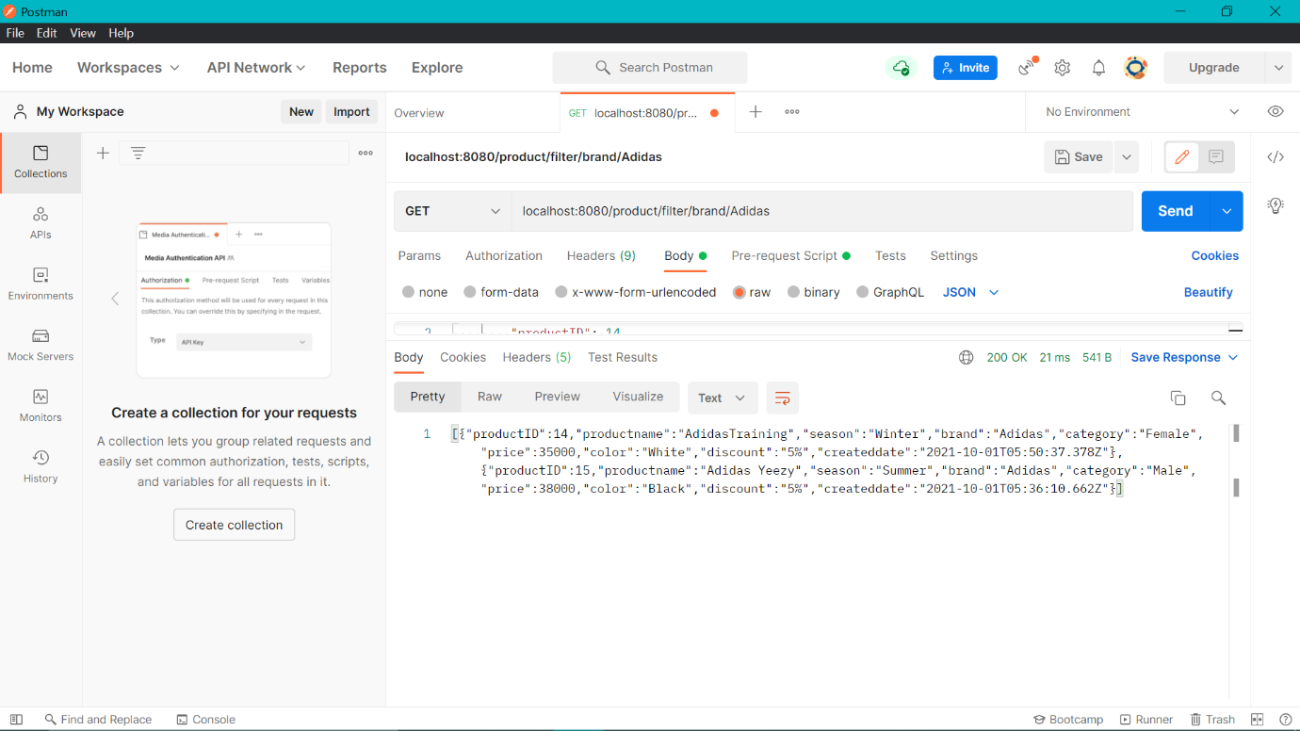

3. Category (Male)  
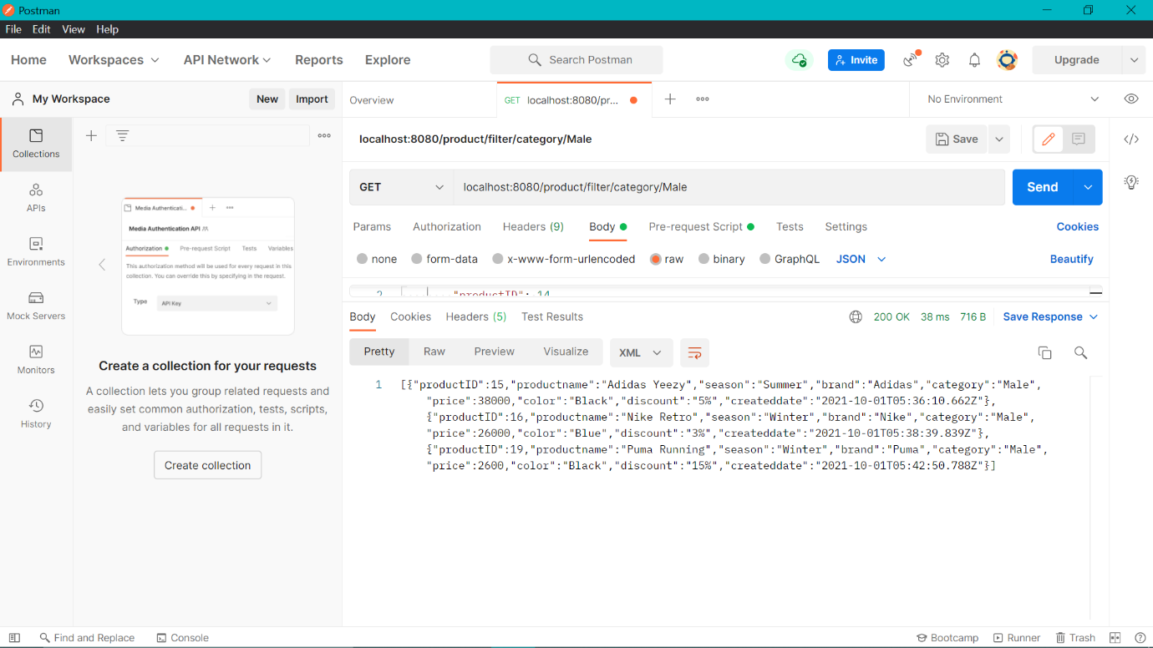

Category (Female)  
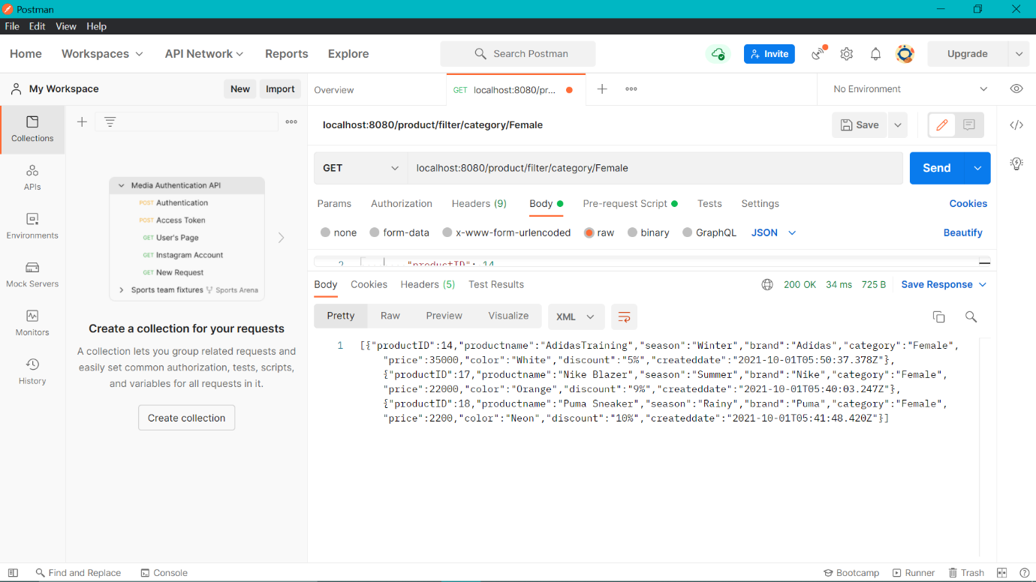

4. Color Filters (Black/Orange/Neon/Pink)  
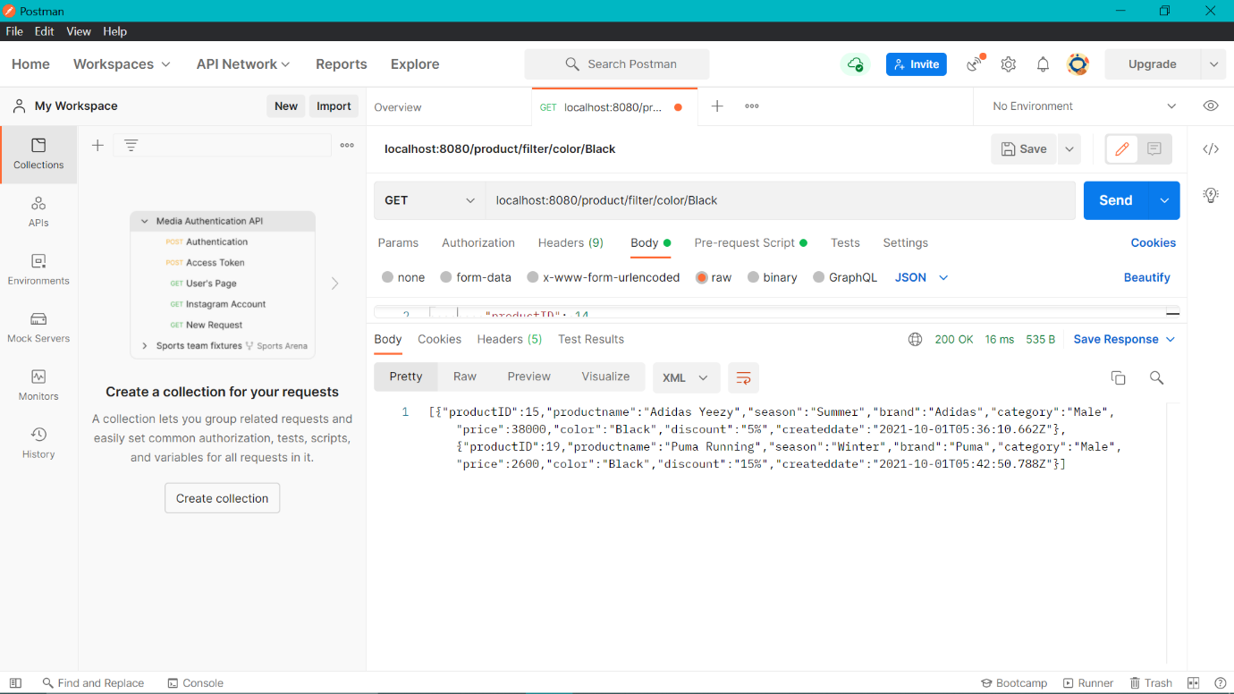

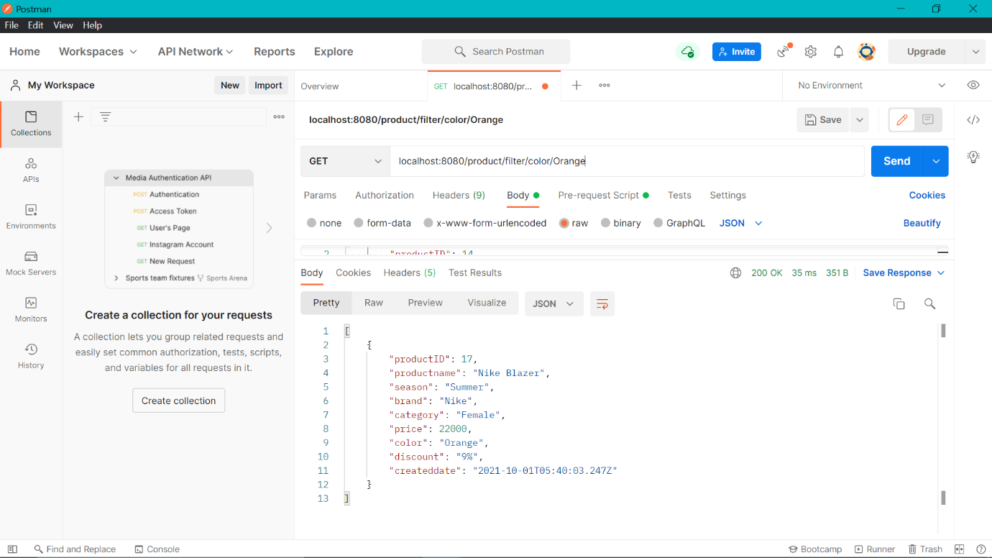

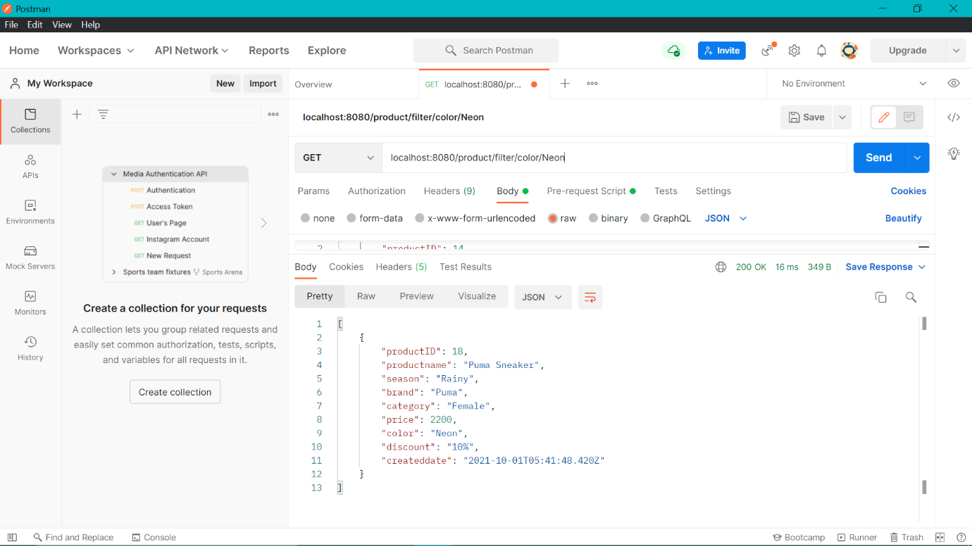

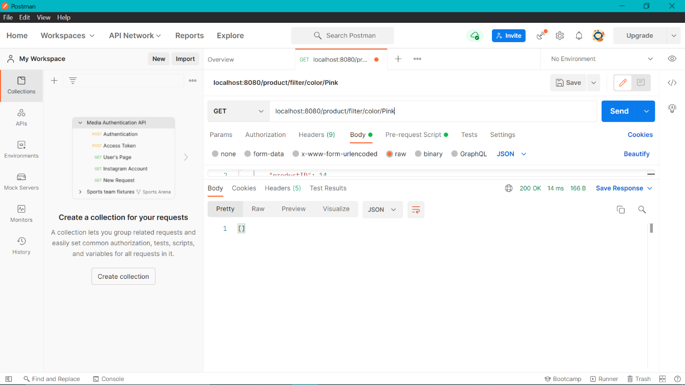

5. Price Filter (High To Low)  
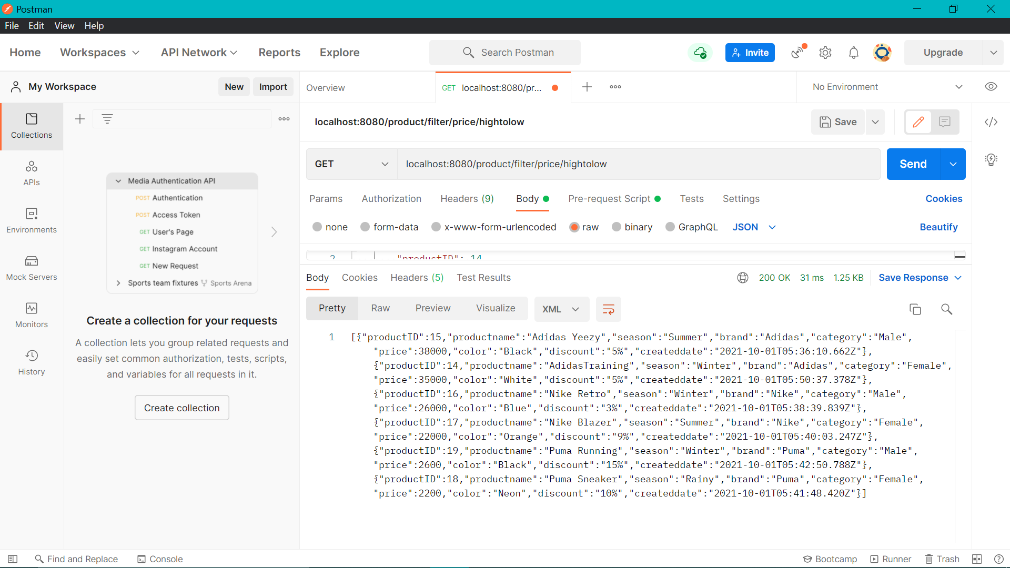

Price Filter (Low To High)  
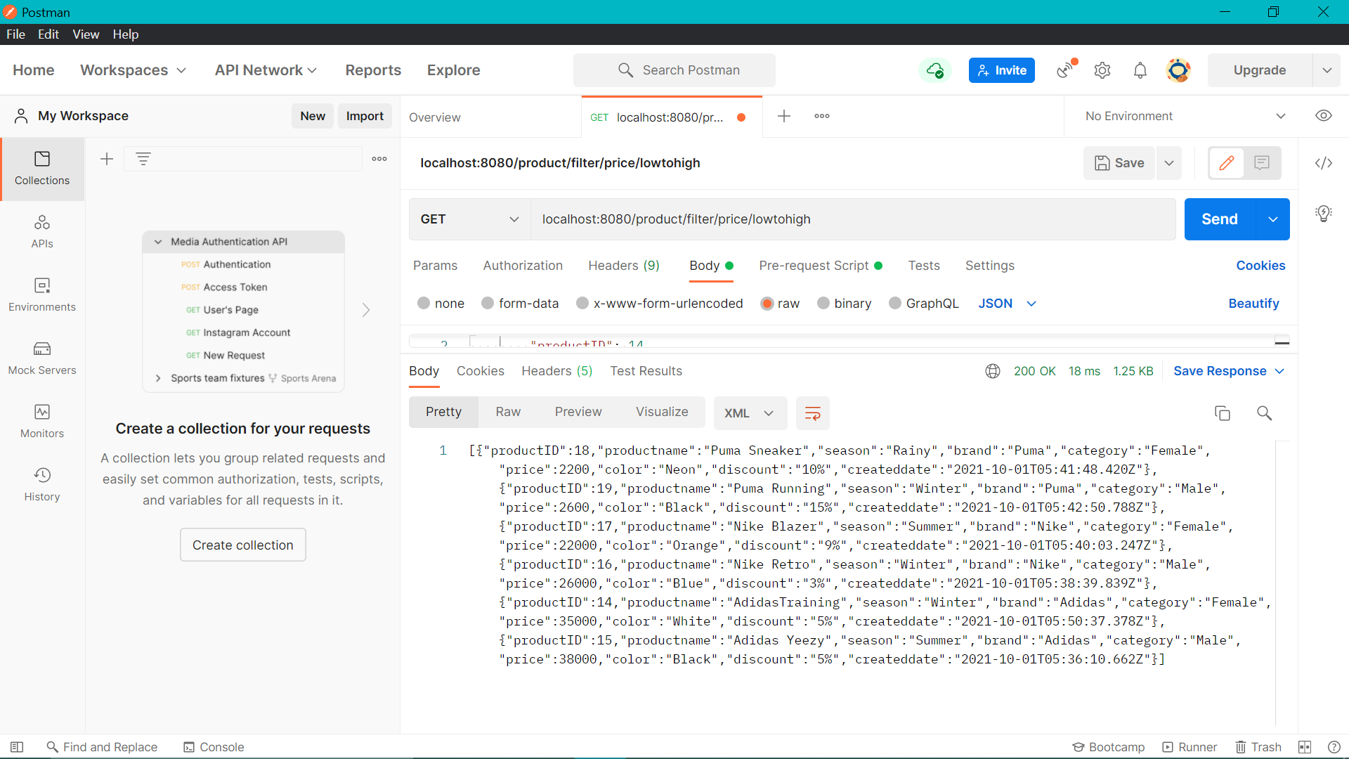

6. Latest Product by brand  
 a. Latest shoe of brand Nike  
 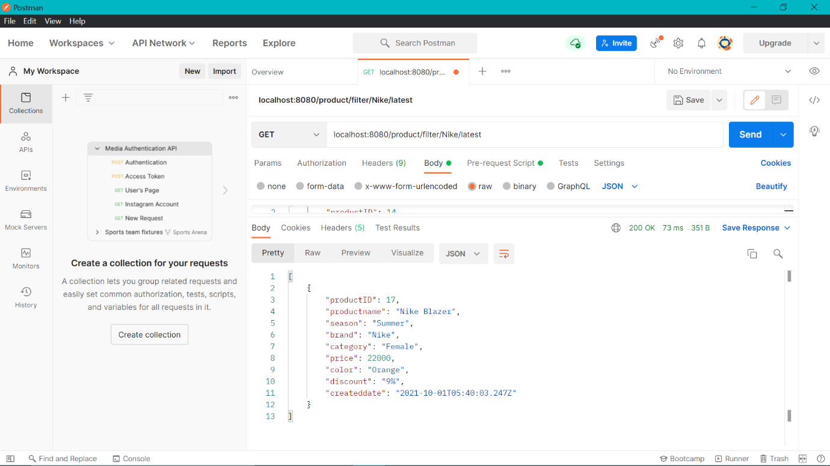

b. Latest shoe of brand Puma  
 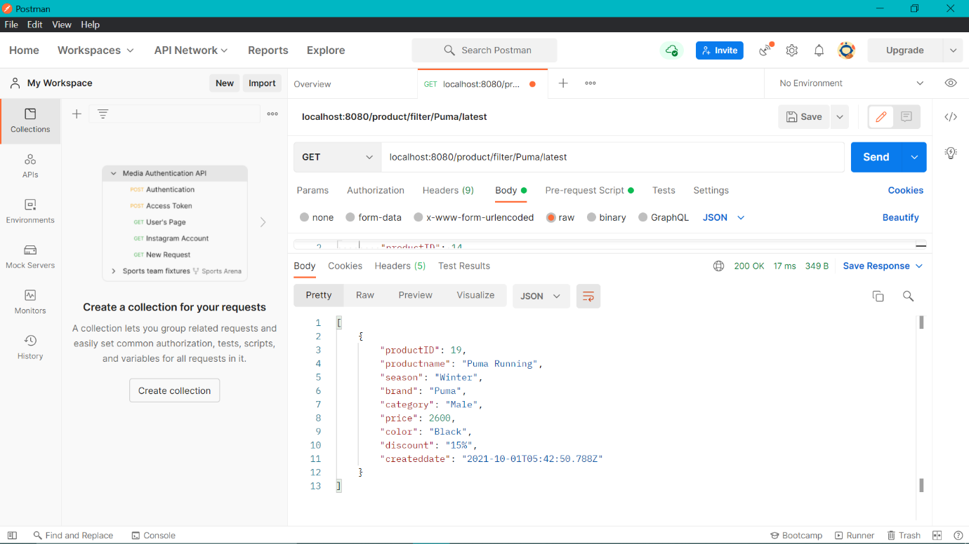

c. Latest shoe of brand Adidas  
 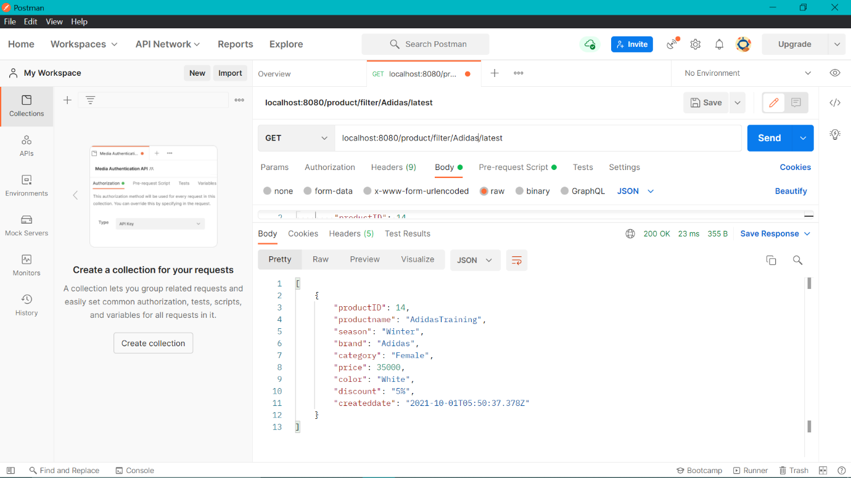

Get All registered Users  
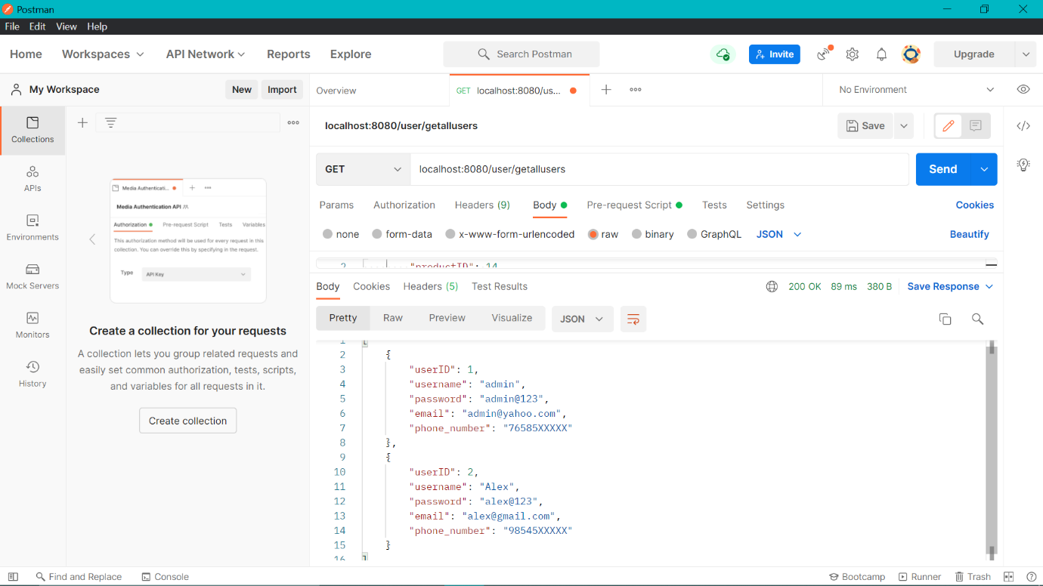

Getting all product details  
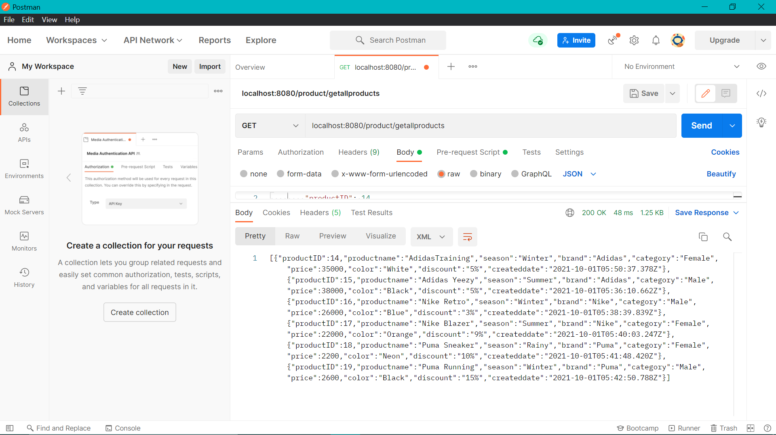

Admin can change the password through API by only providing the new password.  
  
Before Changing the password  
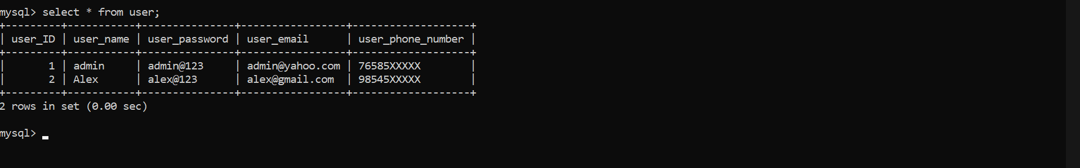

Changing password using API  
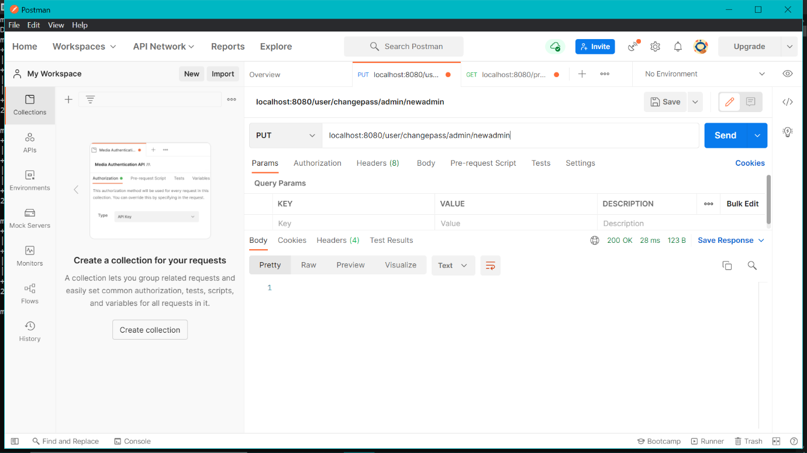

After changing the password  
